***Project Report***

***on***

***NOTES DRIVE***

*A Simple Notes Management System*

*Submitted By,*

* *Rahul Danveer Gupta (27)*

*Thakur Institute of Management Studies, Career Development & Research*



*Educational Campus, Shyamnarayan Thakur Kandivli East, Thakur Shyamnarayan Marg, Thakur Village, Kandivali East, Mumbai, Maharashtra 400101*

**ACKNOWLEDGEMENT**

In writing this project report, it has been our endeavor to present the subject in simple and lucid manner to those who wish to refer it for enhancement or improving the existing features. The knowledge that we have gathered, study of relevant literature for understanding our project, planning of details and suitable software platform by itself and acknowledgement to the industry zeal and technical competence of those many individuals who have contributed to it with profound gratitude, we wish to acknowledge them.

We sincerely thank Thakur Institute of Management Studies, Career Development & Research for training us in the MCA course. We express our deep gratitude to our honorable director Dr. Vinita Gaikwad and we would also express our deep gratitude to our internal guides Ms. Sonu Gupta. Their expertise and insight were invaluable to us during our internship.

**INDEX**

|  |  |  |
| --- | --- | --- |
| Sr no. | Module | Detailed contents |
| 1 | Introduction | * Introduction of the Project * Problem definition * Objective of Project * Scope of Project |
| 2 | Literature of Survey | * Existing System * Proposed System * Module Specification * Knowledge integration * Use cases |
| 3 | Analysis | * Exploring Possibilities * Feasibility Analysis * Cost Benefit Analysis * Flow chart/DED/ER/UML diagram (any other project diagram |
| 4 | Methodology | * Criteria & constraints (Process Models) * Tools used * Procedure |
| 5 | Design and Developing A Prototype | * Module design and organization * Data design * User interface design * Model or Prototype |
| 6 | Project Execution plan | * Plan Using Project Management Tools |
| 7 | Testing & Validation | * Test cases and Report (based on manual & automation testing) |
| 8 | User Manual | * Explanation of Key functions * Method of Implementation * Forms * Output Screens |
| 9 | Conclusion | * Project Conclusion & Future enhancement |

**INTRODUCTION**

**Introduction of the Project**

As the world is being developed with the new technologies, discovering and manipulating new ideas and concepts of taking everything online are rapidly changing. It is difficult for teachers to circulate their notes to each and every student whom is he/she teaching. Notes Gallery provide an easy approach for both students and teachers to circulate the notes whether of any kind like lecture notes, assignment questions, question papers and all the important documents.

The teachers and students can upload the documents from anywhere and students can download it. Overall it is managed by the admin.

This project intends to provide the students with an environment where they can upload their notes online. By doing this, it will allow them to gain the basic knowledge about using any kind of project management system. This project has only a single agenda, that is, to allow students to upload their study materials online like google classroom. Here you have to sign up in order to upload any kind of files. When you sing up then you can view the uploading dashboard. From there you can upload your files and later on you can download them.

Features such as Editing site content, user management, and site settings are the most essential feature of a site. And these all features have made management of site easier as the user can change the content and setting any time, he/she want rather than opening the whole source code and changing each line of codes. A clean and responsive dashboard is provided in the admin panel for the easy management of this project. This project in PHP helps in easy management of the notes and study materials for the students. Design of this project is pretty and responsive so that user won’t find it difficult to understand, use and navigate.

It contains just a user side. All the management are done from the user side like uploading the reading materials. From the user side, the users can view the homepage and see the contents available there. Through this site, the college can maintain the student’s notes with more ease. He She can upload them and also can edit them.

**Problem Definition**

There are many students who face problem in studying at the exam time because either they don’t have the notes provided by teachers or they must have not been in the college. This System will provide a platform to easily access the notes.

A useful fact-finding technique is to research the application or the problem that you are dealing with and want to put within a database. Computer trade journals, reference books, and the Internet are good sources of information which can make available of huge quantity of information on how others have solved similar problems/issues plus whether or not any software packages exist to resolve or even partially solve your current problem.

**Objective of Project**

The Objective of Notes Drive is to provide better facility to the students and teachers to bring out the easy circulation of documents within healthy environment. It will reduce the manual paperwork, reduced the sharing and distribution time.

There can be several objectives for using interviewing such as finding out facts, verifying those facts, clarifying these released facts, generating enthusiasm, getting the end-user involved, identifying requirements, and gathering ideas and opinions. However, using the interviewing practice must require proper communication skills for dealing effectively with people who have different values, priorities, opinions, motivations, and personalities.

**Scope of Project**

The project has a very vast scope in future. The project can be implemented on intranet in future. Project can be updated in near future as and when requirement for the same arises, as it is very flexible in terms of expansion. With the proposed software of Notes Drive will be ready to use by any organization hence run the entire work in a much better, accurate and error free manner. The following are the future scope for the project.

* Only a particular organization people can use this system.
* Unique ID of students and teachers will be generated by the system.
* Mailing system will be done with the message alert system.

**LITERATURE OF SURVEY**

**Existing System & It’s Limitations**

Mostly the notes are circulated on WhatsApp or any kind so it gets very difficult to manage the important notes at the time of need.

**Need of Proposed System**

My system will provide an easy approach to share the documents for studying purpose. Multiple users can work simultaneously on the system. It will be easy for the teachers to circulate the notes to each and every student.

**Intended Audience**

The system will be used by students and teachers in colleges and even it can be used by schools.

**Proposed System**

Problem Statement

There are many students who face problem in studying at the exam time because either they don’t have the notes provided by teachers or they must have not been in the college. This System will provide a platform to easily access the notes.

Objectives of Proposed System

The Objective of Notes Drive is to provide better facility to the students and teachers to bring out the easy circulation of documents within healthy environment. It will reduce the manual paperwork, reduced the sharing and distribution time.

**Module Specification**

* Student: -

Students register on the website and login to access the notes uploaded by teachers and view them or download it.

* Teacher: -

The teacher has to first register on the website and then login to upload the note. Teacher can even delete the notes by logging in.

* Notes: -

Notes can be uploaded and deleted by teacher and student. It can be downloaded by every student and teacher.

* Admin: -

The notes are managed by admin. He has rights to approve or disapprove the notes uploaded by particular user.

**Use Case**

To model a system, the most important aspect is to capture the dynamic behavior. Dynamic behavior means the behavior of the system when it is running/operating.

Only static behavior is not sufficient to model a system rather dynamic behavior is more important than static behavior. In UML, there are five diagrams available to model the dynamic nature and use case diagram is one of them.

These internal and external agents are known as actors. Use case diagrams consists of actors, use cases and their relationships. The diagram is used to model the system/subsystem of an application. A single use case diagram captures a particular functionality of a system.

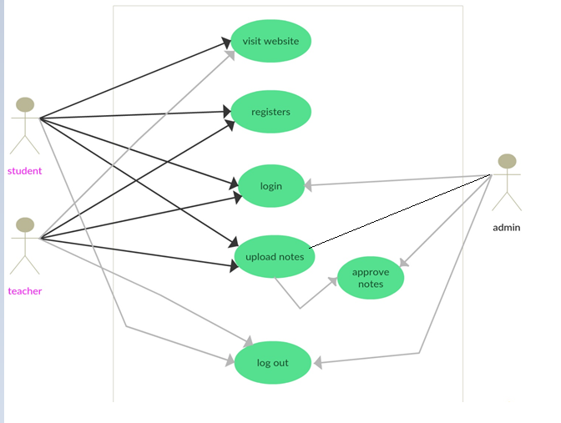

**ANALYSIS**

**Requirement Analysis**

Fact Finding Method

A database developer normally uses several fact-finding techniques during a single database project. There are five commonly used fact-finding techniques:

* Examining Documentation
* Interviewing
* Observation the enterprise in action
* Research
* Questionnaire

Let us discuss in brief each of them:

* Examining Documentation

Examining documentation can be helpful when you try to gain some insight as to how the requirement for a database arose. You may also find that documentation can help to acquire information on the part of the enterprise associated with the problem. If the problem relates to the current system, there should have to be documents associated with that system. By examining documents, forms, reports, and files associated with the current system, you can quickly gain some thoughtful concepts out of the system.

* Interviewing

Interviewing is the most frequently used, and usually most useful, fact-finding procedure used. We can interview to collect information from person face-to-face. There can be several objectives for using interviewing such as finding out facts, verifying those facts, clarifying these released facts, generating enthusiasm, getting the end-user involved, identifying requirements, and gathering ideas and opinions. However, using the interviewing practice must require proper communication skills for dealing effectively with people who have different values, priorities, opinions, motivations, and personalities.

* Observing the Enterprise in action

Observation is one of the most successful fact-finding techniques carried out for understanding a system. Using this technique, it is achievable to either participate in or observe a person perform activities to learn about the system.

* Research

A useful fact-finding technique is to research the application or the problem that you are dealing with and want to put within a database. Computer trade journals, reference books, and the Internet are good sources of information which can make available of huge quantity of information on how others have solved similar problems/issues plus whether or not any software packages exist to resolve or even partially solve your current problem.

* Questionnaires

Another fabulous fact-finding method is to conduct surveys through questionnaires. Questionnaires are special-purpose documents that allow facts to be gathered from a large number of people while upholding some control over their responses. When dealing with a large number of listeners or audience, no other fact-finding technique can tabulate the same facts so efficiently. There are two types of questions that can be asked in a questionnaire namely free-format and fixed-format. Free-format questions offer the respondent greater freedom inputting answers. Fixed-format questions require specific responses from individuals, and for the given question, the respondent must choose from the available answers.

**Feasibility Study**

Feasibility Study can be considered as preliminary investigation that helps the management to take decision about whether study of system should be feasible for development or not.

It identifies the possibility of improving an existing system, developing a new system, and produce refined estimates for further development of system.

It is used to obtain the outline of the problem and decide whether feasible or appropriate solution exists or not.

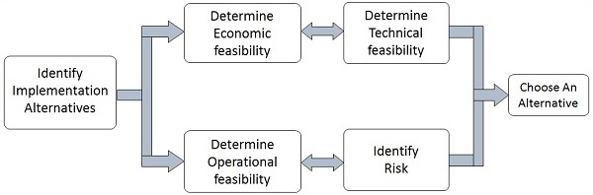

The main objective of a feasibility study is to acquire problem scope instead of solving the problem.

Steps Involved in Feasibility Analysis

The following steps are to be followed while performing feasibility analysis

Form a project team and appoint a project leader.

* Develop system flowcharts.
* Identify the deficiencies of current system and set goals.
* Enumerate the alternative solution or potential candidate system to meet goals.
* Determine the feasibility of each alternative such as technical feasibility, operational feasibility, etc.
* Weight the performance and cost effectiveness of each candidate system.
* Rank the other alternatives and select the best candidate system.
* Prepare a system proposal of final project directive to management for approval.

**Types of Feasibilities**

* Economic Feasibility

It is evaluating the effectiveness of candidate system by using cost/benefit analysis method.

It demonstrates the net benefit from the candidate system in terms of benefits and costs to the organization.

The main aim of Economic Feasibility Analysis (EFS) is to estimate the economic requirements of candidate system before investments funds are committed to proposal.

It prefers the alternative which will maximize the net worth of organization by earliest and highest return of funds along with lowest level of risk involved in developing the candidate system.

* Technical Feasibility

It investigates the technical feasibility of each implementation alternative.

It analyses and determines whether the solution can be supported by existing technology or not.

The analyst determines whether current technical resources be upgraded or added it that full fill the new requirements.

It ensures that the candidate system provides appropriate responses to what extent it can support the technical enhancement.

* Operational Feasibility

It determines whether the system is operating effectively once it is developed and implemented.

It ensures that the management should support the proposed system and its working feasible in the current organizational environment.

It analyses whether the users will be affected and they accept the modified or new business methods that affect the possible system benefits.

It also ensures that the computer resources and network architecture of candidate system are workable.

* Behavioral Feasibility

It evaluates and estimates the user attitude or behaviour towards the development of new system.

It helps in determining if the system requires special effort to educate, retrain, transfer, and changes in employee’s job status on new ways of conducting business.

* Schedule Feasibility

It ensures that the project should be completed within given time constraint or schedule.

It also verifies and validates whether the deadlines of project are reasonable or not.

**Cost Benefit Analysis**

* Market Analysis

A market analysis is an assessment, which allows you to determine how suitable a particular market is for your industry. You can use market analysis to evaluate your current market, or look at new markets.

Whether you are a start-up, looking to expand, or revaluating your current market, a market analysis helps you to identify the attractiveness of a market. It also detects current and future risks of operating in that location.

Market analysis provides you with a holistic, or well-rounded picture of the markets you are interested in operating in. The components of the analysis include several evaluation tools, including a discussion of your industry and its outlook in the market. It also analyses the target market, conducts a competitive analysis, and identifies cultural and legal regulations.

* Technical Analysis

In finance, technical analysis is an analysis methodology for forecasting the direction of prices through the study of past market data, primarily price and volume. Behavioral economics and quantitative analysis use many of the same tools of technical analysis, which, being an aspect of active management, stands in contradiction to much of modern portfolio theory. The efficacy of both technical and fundamental analysis is disputed by the efficient-market hypothesis which states that stock market prices are essentially unpredictable.

* Financial Analysis

Financial analysis is the process of evaluating businesses, projects, budgets and other finance-related entities to determine their performance and suitability. Typically, financial analysis is used to analyses whether an entity is stable, solvent, liquid or profitable enough to warrant a monetary investment. When looking at a specific company, a financial analyst conducts analysis by focusing on the income statement, balance sheet, and cash flow statement.

**Sequence Diagram**

A sequence diagram simply depicts interaction between objects in

a sequential order i.e. the order in which these interactions take place. We can

also use the terms event diagrams or event scenarios to refer to a sequence

diagram. Sequence diagrams describe how and in what order the objects in a

system function.

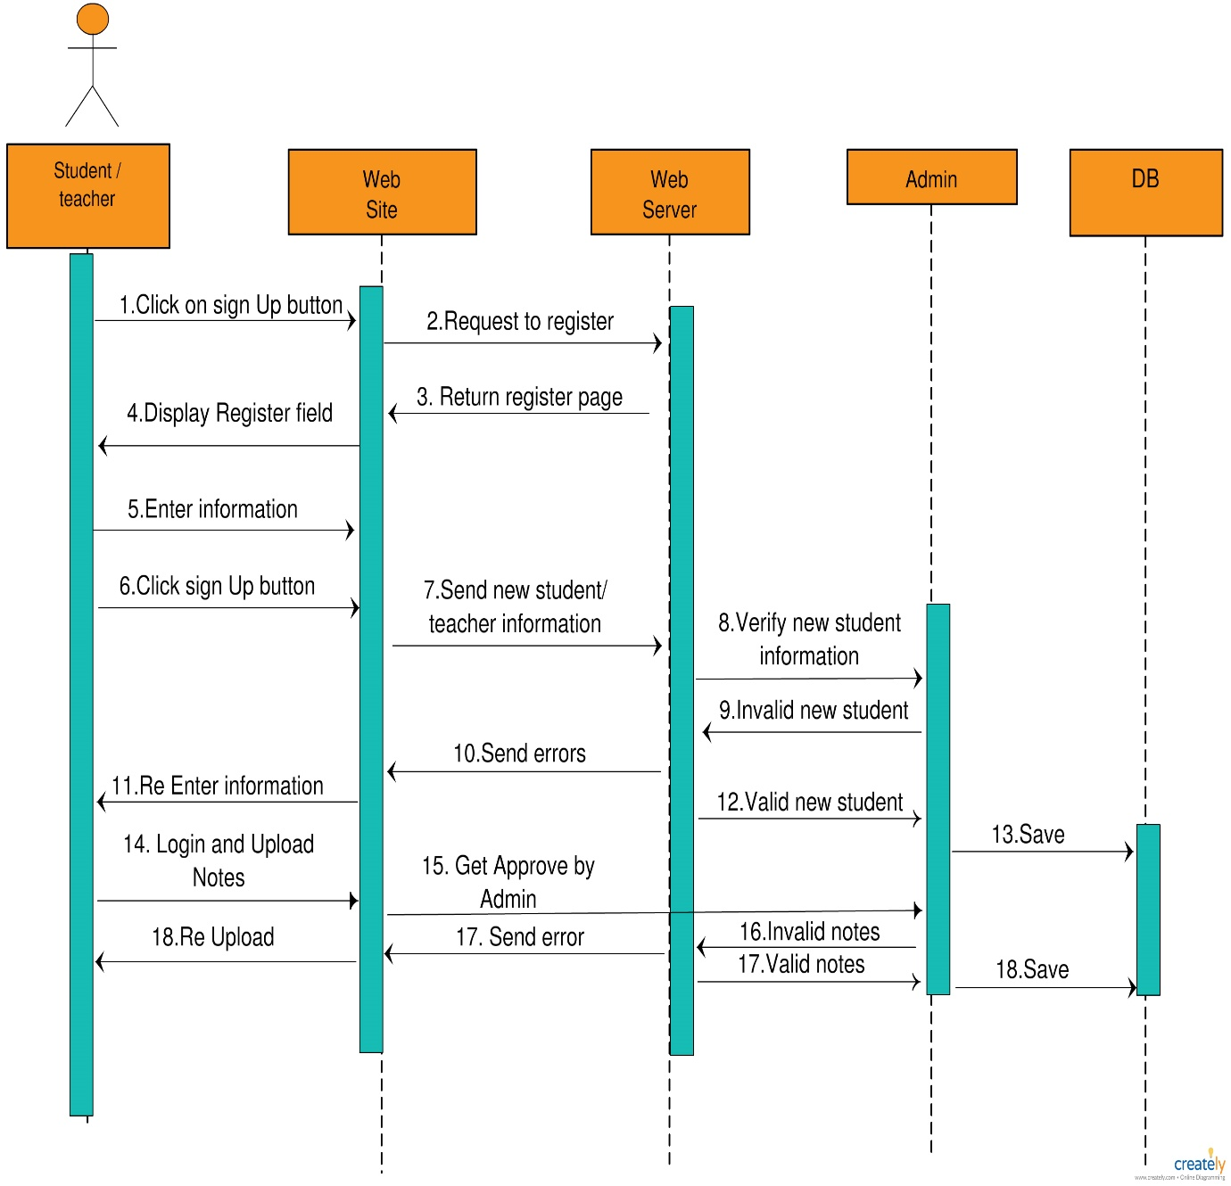

**Class Diagram**

Class diagram is a static diagram. It represents the static view of an application. Class diagram is not only used for visualizing, describing, and documenting different aspects of a system but also for constructing executable code of the software application. Class diagram describes the attributes and operations of a class and also the constraints imposed on the system. The class diagrams are widely used in the modelling of object-oriented systems because they are the only UML diagrams, which can be mapped directly with object-oriented languages.

Class diagram shows a collection of classes, interfaces, associations, collaborations, and constraints. It is also known as a structural diagram.

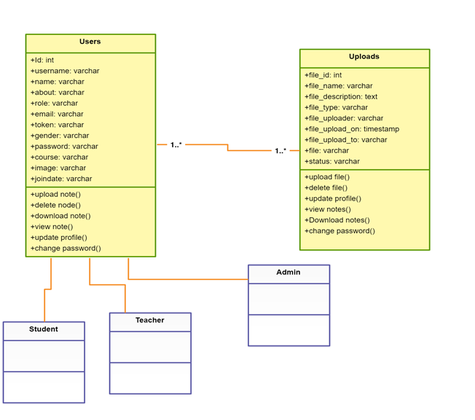

**Entity Relationship Diagram**

Entity relationship diagram displays the relationships of entity set stored in a database. In other words, we can say that ER diagrams help you to explain the logical structure of databases. At first look, an ER diagram looks very similar to the flowchart. However, ER Diagram includes many specialized symbols, and its meanings make this model unique.

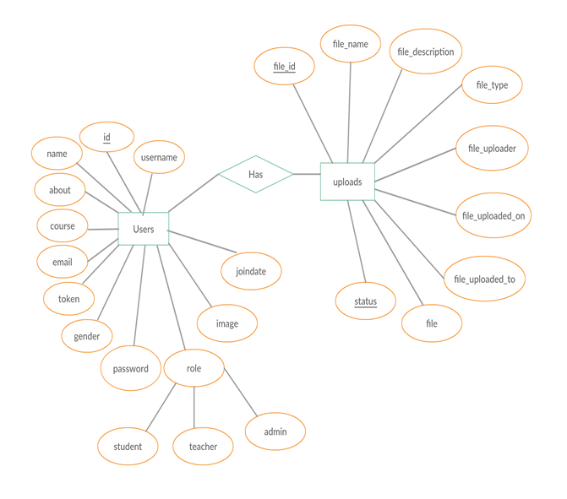

**Data Flow Diagram**

A data flow diagram (DFD) is a way of representing a flow of a data of a process or a system (usually an information system) The DFD also provides information about the outputs and inputs of each entity and the process itself. A data flow diagram has no control flow, there are no decision rules and no loops. Specific operations based on the data can be represented by a flowchart.

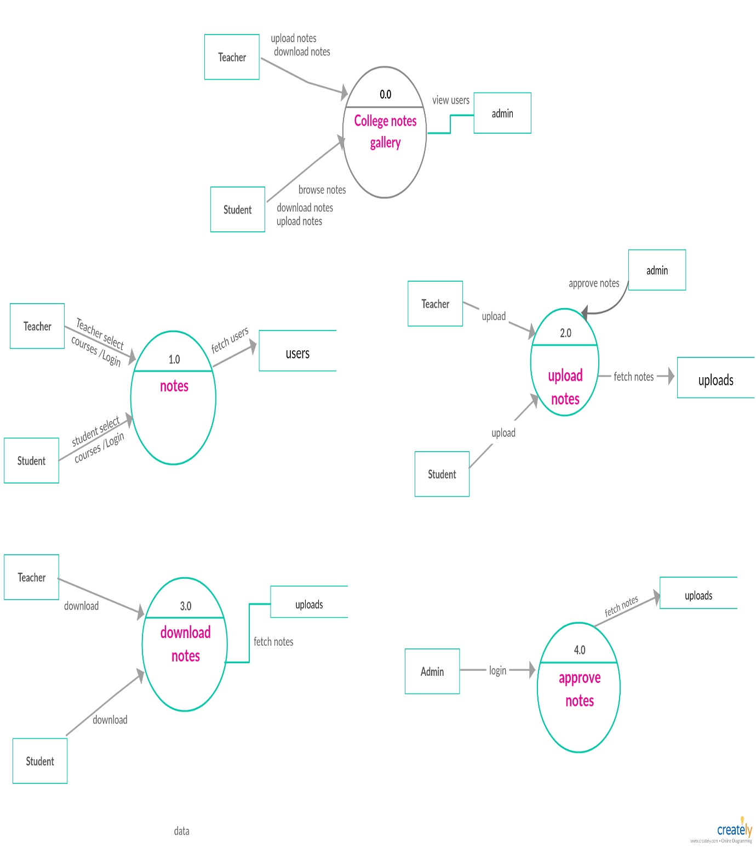

**METHODOLOGY**

**Criteria & Constraints [Process Model]**

Process Management System:

Process management is an ensemble of the activities of planning and monitoring the performance of a business process.

In this era of rapid technological innovations and changes, the success of an organization lies in the continual improvement of its processes and its ability to leverage its effectiveness for business excellence.

Notes Drive help to share the notes to every person.

Waterfall Model

The Waterfall Model was the first Process Model to be introduced. It is also referred to as a linear-sequential life cycle model. It is very simple to understand and use. In a waterfall model, each phase must be completed before the next phase can begin and there is no overlapping in the phases.

The Waterfall model is the earliest SDLC approach that was used for software development.

The waterfall Model illustrates the software development process in a linear sequential flow. This means that any phase in the development process begins only if the previous phase is complete. In this waterfall model, the phases do not overlap.

Waterfall Model - Design

Waterfall approach was first SDLC Model to be used widely in Software Engineering to ensure success of the project. In "The Waterfall" approach, the whole process of software development is divided into separate phases. In this Waterfall model, typically, the outcome of one phase acts as the input for the next phase sequentially.

The following illustration is a representation of the different phases of the Waterfall Model.

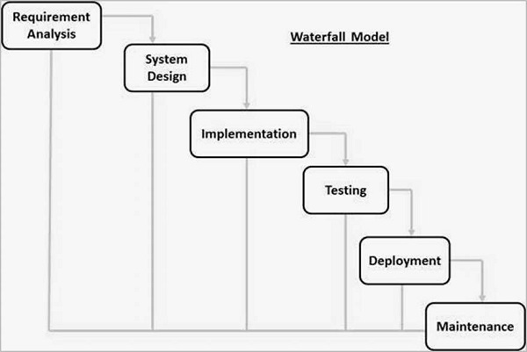

The sequential phases in Waterfall model are −

* Requirement Gathering and analysis

All possible requirements of the system to be developed are captured in this phase and documented in a requirement specification document.

* System Design

The requirement specifications from first phase are studied in this phase and the system design is prepared. This system design helps in specifying hardware and system requirements and helps in defining the overall system architecture.

* Implementation

With inputs from the system design, the system is first developed in small programs called units, which are integrated in the next phase. Each unit is developed and tested for its functionality, which is referred to as Unit Testing.

* Integration and Testing

All the units developed in the implementation phase are integrated into a system after testing of each unit. Post integration the entire system is tested for any faults and failures.

* Deployment of system

Once the functional and non-functional testing is done; the product is deployed in the customer environment or released into the market.

* Maintenance

There are some issues which come up in the client environment. To fix those issues, patches are released. Also, to enhance the product some better versions are released. Maintenance is done to deliver these changes in the customer environment.

All these phases are cascaded to each other in which progress is seen as flowing steadily downwards (like a waterfall) through the phases. The next phase is started only after the defined set of goals are achieved for previous phase and it is signed off, so the name "Waterfall Model". In this model, phases do not overlap.

**Tools used**

Operating Environment

**Hardware Requirements**

* CORE 2 Duo PROCESSOR
* RAM 1 GB
* HARD DISK 10 GB
* CACHE MEMORY 512 KB

**Software Requirements**

* WINDOWS OPERATING SYSTEM
* PHP
* MySQL
* HTML, CSS, JAVASCRIPT, BOOTSTRAP
* XAMP
* APACHE SERVER
* SUBLIME TEXT EDITOR

**Procedure**

Interviewing is the most frequently used, and usually most useful, fact-finding procedure used. We can interview to collect information from person face-to-face. There can be several objectives for using interviewing such as finding out facts, verifying those facts, clarifying these released facts, generating enthusiasm, getting the end-user involved, identifying requirements, and gathering ideas and opinions. However, using the interviewing practice must require proper communication skills for dealing effectively with people who have different values, priorities, opinions, motivations, and personalities.

When the project management team and or the project management team leader begins the process of managing a particular project and or series of projects, it is fundamentally important to establish a series of hard and fast guidelines that are in place for the purposes of both maintaining and achieving a level of constancy among the team but also to provide for a simple place to go to find out the answer to the simple question “How?” without having to reinvent the wheel constantly along the way. For these purposes, it is wise for the project management team and or the project management team leader to implement a set and fast series of procedures for the course of the project and or projects. The procedure refers to a highly detailed series of specific steps that are to be taken over the course of the project. These are typically to be followed in a highly specific order as well, and in most cases, the endpoint of the procedure as a whole is the accomplishment of a pre-specified task of sorts, in this case, completion of the project and or of a particular phase thereof.

This term is defined in the 3rd edition of the PMBOK but not in the 4th.

Documented Procedure The phrase documented procedure refers to the utilization of a written document as described under the definition above for document...

Process The concept of process is very closely interrelated to the concept of procedure when it comes to the function of...

Schedule Compression Methodology In project management, there are tradeoffs between meeting an earlier deadline through schedule compression and keeping costs down...

**DESIGN & DEVELOPING A PROTOTYPE**

**Module design and organization**

Modular design is an approach in which engineering projects, even complex ones, are created using standard modules, aka “typically.” You can then combine these modules in different ways depending on the needs of the project.

For organizations looking to reduce project costs (i.e., any organization involved in engineering or construction), taking a modular design approach can be a game-changer, especially for greenfield projects. It can make the difference between operating in the black, rather than in the red. And not just on a short-term project basis, but over the long haul.

7 benefits of modular project design.

* Saving time and money
* Reducing rework and leveraging organizational knowledge
* Futureproofing
* Customizing made easy
* Concurrent engineering
* Outsourcing
* Tracking and analyzing data

**Data Design**

Data design is the first design activity, which results in less complex, modular and efficient program structure. The information domain model developed during analysis phase is transformed into data structures needed for implementing the software. The data objects, attributes, and relationships depicted in entity relationship diagrams and the information stored in data dictionary provide a base for data design activity. During the data design process, data types are specified along with the integrity rules required for the data. For specifying and designing efficient data structures, some principles should be followed. These principles are listed below.

The data structures needed for implementing the software as well-as the operations that can be applied on them should be identified.

A data dictionary should be developed to depict how different data objects interact with each other and what constraints are to be imposed on the elements of data structure.

Stepwise refinement should be used in data design process and detailed design decisions should be made later in the process.

Only those modules that need to access data stored in a data structure directly should be aware of the representation of the data structure.

A library containing the set of useful data structures along with the operations that can be performed on them should be maintained.

Language used for developing the system should support abstract data types.

The structure of data can be viewed at three levels, namely, program component level, application level, and business level. At the program component level, the design of data structures and the algorithms required to manipulate them is necessary, if high-quality software is desired. At the application level, it is crucial to convert the data model into a database so that the specific business objectives of a system could be achieved. At the business level, the collection of information stored in different databases should be reorganized into data warehouse, which enables data mining that has an influential impact on the business.

**User Interface Design**

What is user interface design?

User interface design or UI design generally refers to the visual layout of the elements that a user might interact with in a website, or technological product. This could be the control buttons of a radio, or the visual layout of a webpage. User interface designs must not only be attractive to potential users, but must also be functional and created with users in mind.

Why is user interface design important for usability?

User interface design can dramatically affect the usability and user experience of an application. If a user interface design is too complex or not adapted to targeted users, the user may not be able to find the information or service they are looking for. In website design, this can affect conversion rates. The layout of a user interface design should also be clearly set out for users so that elements can be found in a logical position by the user.

How to optimize user interface design

User interface designs should be optimized so that the user can operate an application as quickly and easily as possible. Many experts believe that UI design should be simple and intuitive, often using metaphors from non-computer systems. With a more intuitive user interface design, users will be able to navigate around a website easily, finding the product or service they want quickly. One way to check the intuitiveness of a user interface design is through usability testing. The feedback from usability testing can then be used to optimize the user interface design of a prototype or final product.

**Model or Prototype**

Model

One of the basic notions of the software development process is SDLC models which stands for Software Development Life Cycle models. SDLC – is a continuous process, which starts from the moment, when it’s made a decision to launch the project, and it ends at the moment of its full remove from the exploitation. There is no one single SDLC model. They are divided into main groups, each with its features and weaknesses.

Evolving from the first and oldest “waterfall” SDLC model, their variety significantly expanded. The SDLC model’s diversity is predetermined by the wide number of product types – starting with a web application development to a complex medical software. And if you take one of the SDLC models mentioned below as the basis – in any case, it should be adjusted to the features of the product, project, and company. The most used, popular and important SDLC models are given below:

* Waterfall model
* Iterative model
* Spiral model
* V-shaped model
* Agile model

**Prototype**

What is Software Prototyping Model?

Prototype methodology is defined as a Software Development model in which a prototype is built, test, and then reworked when needed until an acceptable prototype is achieved. It also creates a base to produce the final system.

Software prototyping model works best in scenarios where the project's requirement is not known. It is an iterative, trial, and error method which take place between the developer and the client.

Prototyping Model Phases:

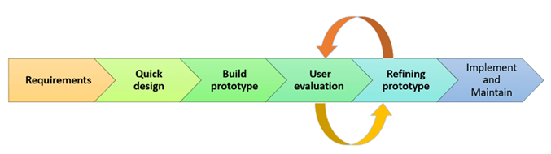

Prototyping Model has following six SDLC phases as follow:

* Requirements gathering and analysis
* Quick design
* Build a Prototype
* Initial user evaluation
* Refining prototype
* Implement Product and Maintain

**SYSTEM DESIGN**

**Database Dictionary**

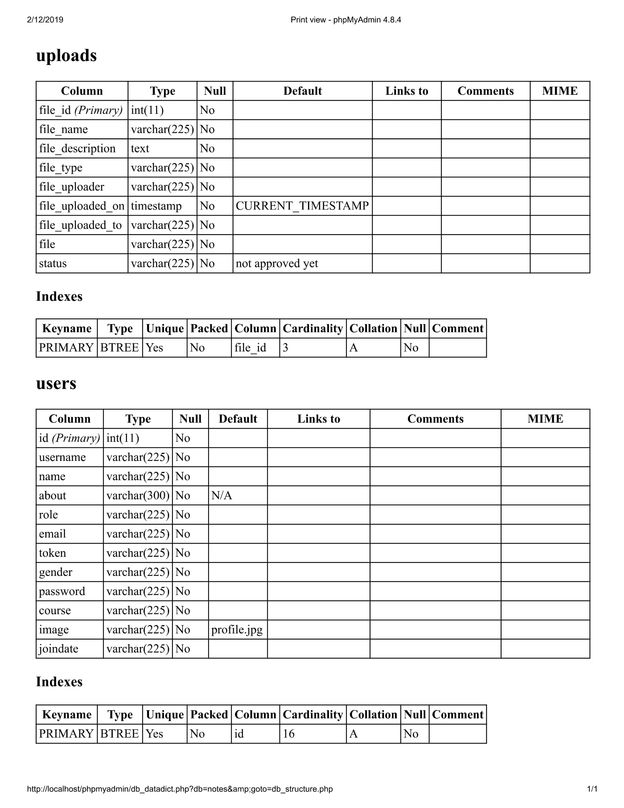

**Tables**

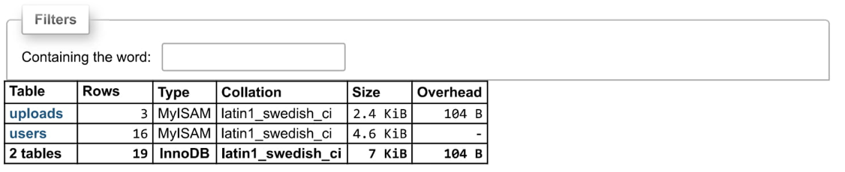

**Uploads Table**

This table is used to store the data uploaded by student or teacher.

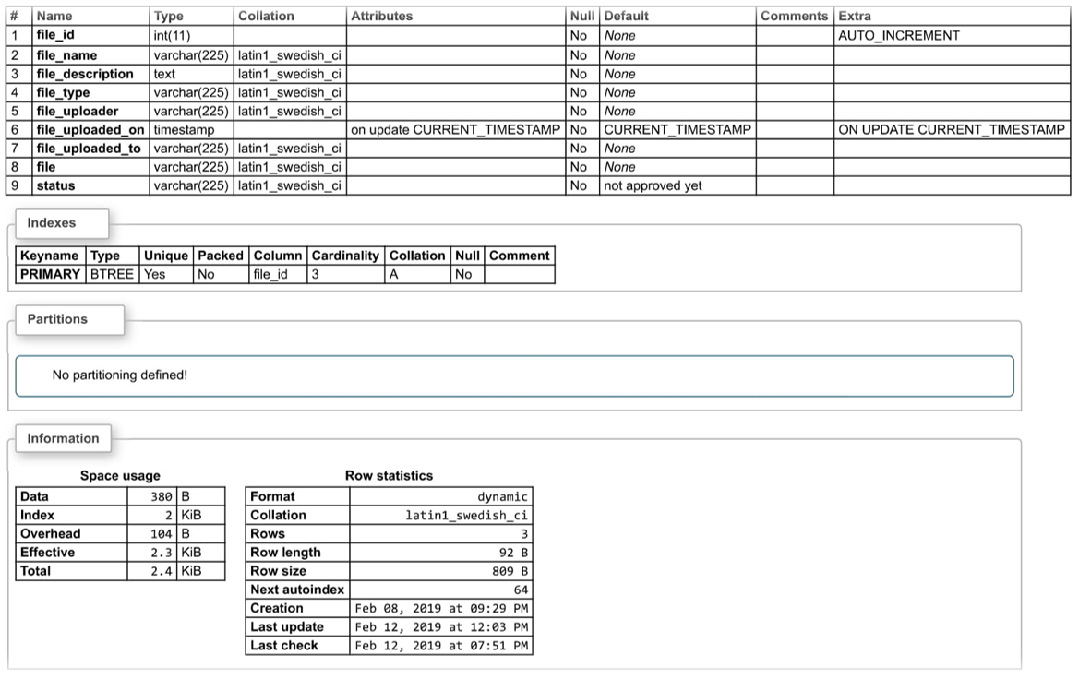

**Uploads Table Data**

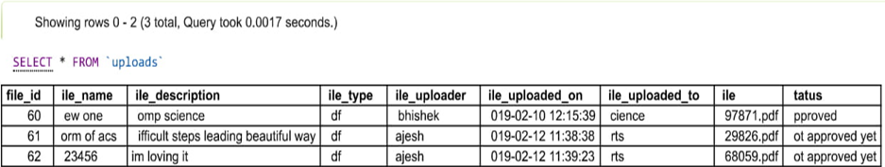

**Users Table**

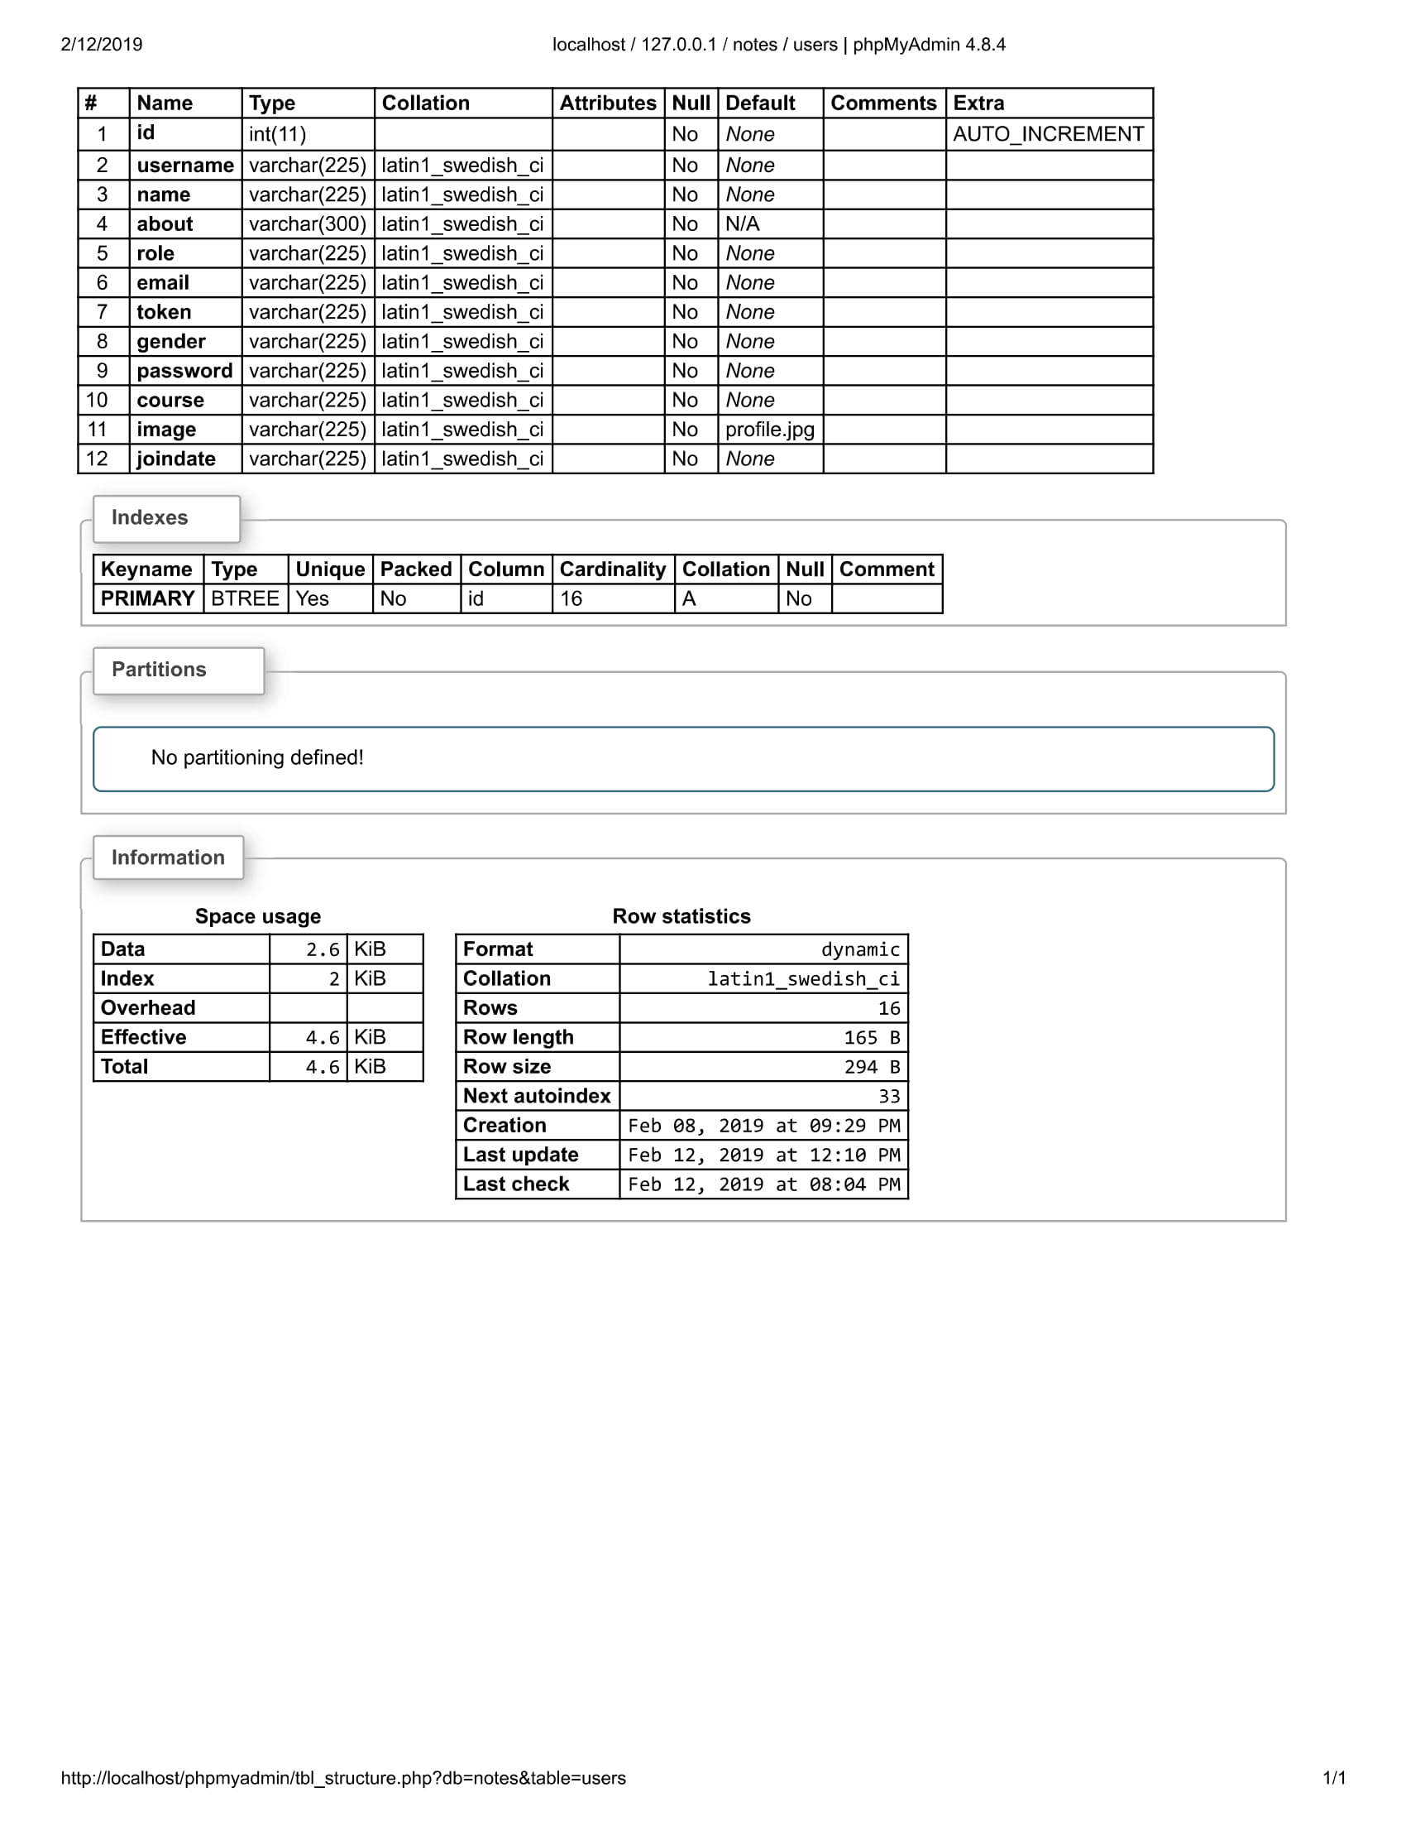

**Users Table Data**

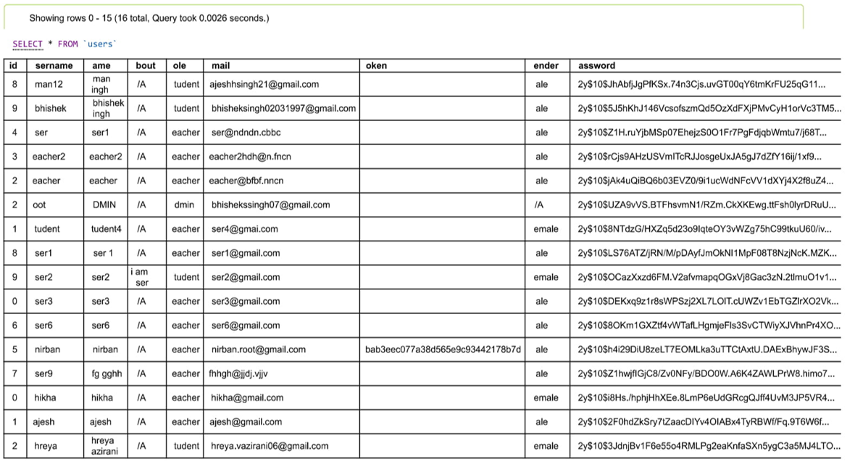

**PROJECT EXECUTION PLAN**

**Plan Using Project Management Tool**

Notes Drive is a release notes manager designed with high throughput in mind, supporting fast distributed development teams without introducing additional development processes. Our goal is to encourage detailed and accurate release notes for every release.

Notes Drive uses MySQL to store its data, alongside the code being described. This means release notes can be written when the code changes are fresh, so no details are forgotten. It also means that release notes can go through the same review process used for managing code and other documentation changes.

Notes Drive release each note in a separate file to enable a large number of developers to work on multiple patches simultaneously, all targeting the same branch, without worrying about merge conflicts. This cuts down on the need to rebase or otherwise manually resolve conflicts, and keeps a development team moving quickly. Notes Drive organizes notes into logical groups based on whether they describe new features, bug fixes, known issues, or other topics of interest to the user. Contributors categorize individual notes as they are added, and reno combines them before publishing.

Notes can be styled using PHP MYSQL directives, and NOTES DRIVE makes it easy to incorporate release notes into automated documentation builds.Notes are automatically associated with the release version based on the git tags applied to the repository, so it is not necessary to track changes manually using a bug tracker or other tool, or to worry that an important change will be missed when the release notes are written by hand all at one time, just before a release.

Modifications to notes are incorporated when the notes are shown in their original location in the history. This feature makes it possible to correct typos or otherwise fix a published release note after a release is made, but have the new note content associated with the original version number. Notes also can be deleted, eliminating them from future documentation builds.

**Testing and Validation**

The aim of the system testing process was to determine all defects in our project. The program was subjected to a set of test inputs and various observations were made and based on these observations it will be decided whether the program behaves as expected or not. Our Project went through two levels of testing.

* Unit testing
* Integration testing
* Unit Testing

Unit testing is undertaken when a module has been created and successfully reviewed. In order to test a single module, we need to provide a complete environment i.e. besides the module we would require The procedures belonging to other modules that the module under test calls Non local data structures that module accesses A procedure to call the functions of the module under test with appropriate parameters.

* Testing admin login form

This form is used for log in of administrator of the system. In this we enter the username and password if both are correct administration page will open other wise if any of data is wrong it will get redirected back to the login page and again ask for username and password.

* Student account addition

In this section the admin can verify student details from student academic info and then only add student details to main Notes database it contains upload and download buttons if user click upload button data will be added to notes drive database and if he clicks download button the notes data will be downloaded.

* Book Addition

Admin can approve the note which was uploaded by a student one-time admin will verify the notes later then he will approve uploaded notes.

* Test for Student login module
* Test for Student login Form

This form is used for log in of Student. In this we enter username and password if all these are correct student login page will open other wise if any of data is wrong it will get redirected back to the login page and again ask for username and password.

* Test for account creation

This form is used for new account creation when student does not fill the form completely it asks again to fill the whole form when he fill the form fully it gets redirected to page which show directly login page in where the student must their selected username which they used in sign up page and enter the password.

* Test for teacher login module

This form is used for log in of Teacher. In this we enter username and password if all these are correct Teacher login page will open otherwise if any of data is wrong it will get redirected back to the login page and again ask for username and password.

**Integration Testing**

In this type of testing we test various integration of the project module by providing the input. The primary objective is to test the module interfaces in order to ensure that no errors are occurring when one module invokes the other module.

**5 User Manual**

Explanation of key Function

* Login

The user can login using the username and password it has registered with. After login, the user can Upload and Download their Notes.

* Registration

A new user has to register first until then he cannot upload or Download the Notes.

* Notes Drive

The main page of the Website login, signup, Upload Notes and About us.

* Upload Notes

Once the User can get login. Teacher or Student can upload their Notes on the website.

* Admin (Add/Update/Delete Notes)

Admin can add, update, Delete notes option is given to the admin.

**Method of Implementation**

In today's society, online buying has adapted to the fast-paced lifestyle, making customers enjoy the convenience of choosing and buying their favorite products at home. This system is based on HTML architecture and adopts PHP, Dreamweaver, MYSQL, PHP and HTML and other related technologies. The foreground system achieves some functions including the user registration and login, upload their Notes and personal information management, etc. And the background system achieves functions including the administrator login, approving and the notes uploaded by the students and teachers, the news and information management, and so on. When released, this system will be dynamic and interactive, and become an online note reading system which is operated easily and has many functions. Keywords: online notes for study and Download, online login and editing their profile in Notes drive systems, PHP.

**Forms and Outputs**

* **HOMEPAGE:**



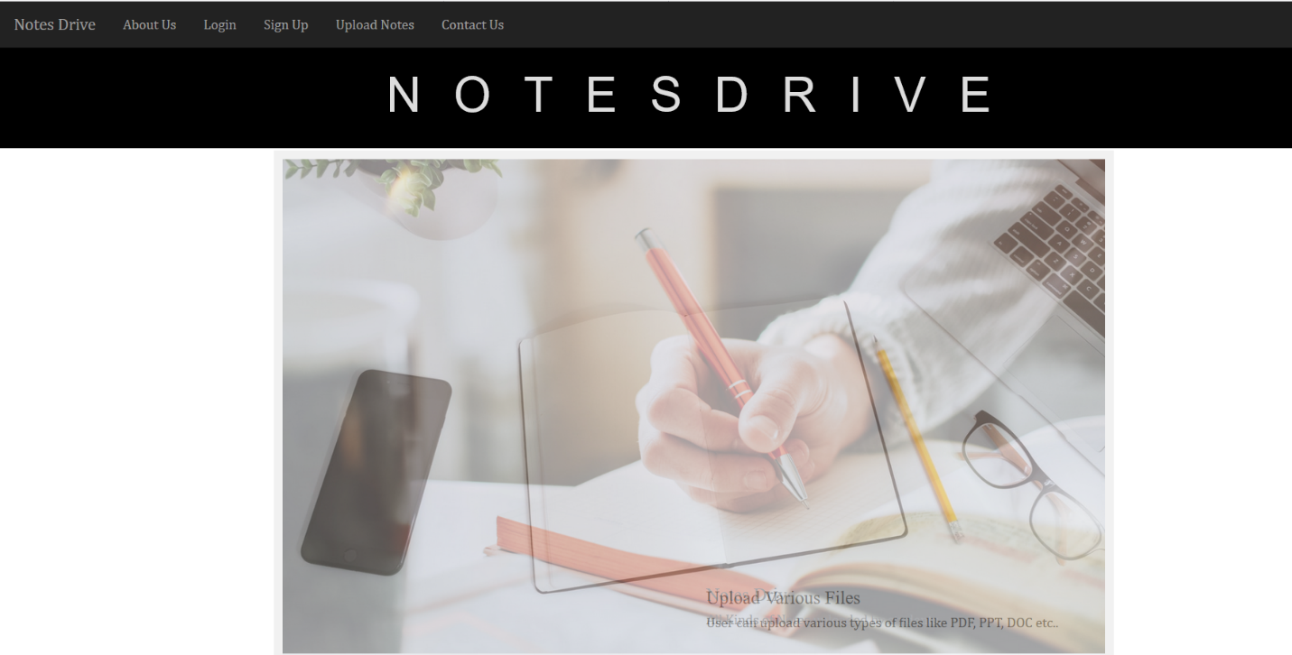

* **About Page**

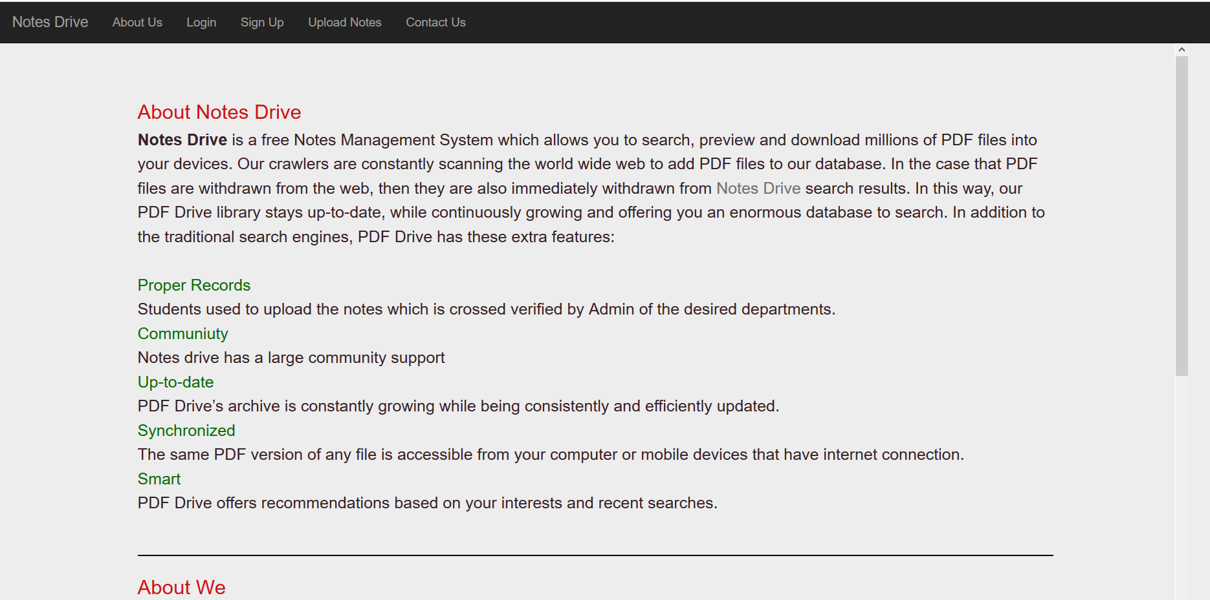

* Login Page

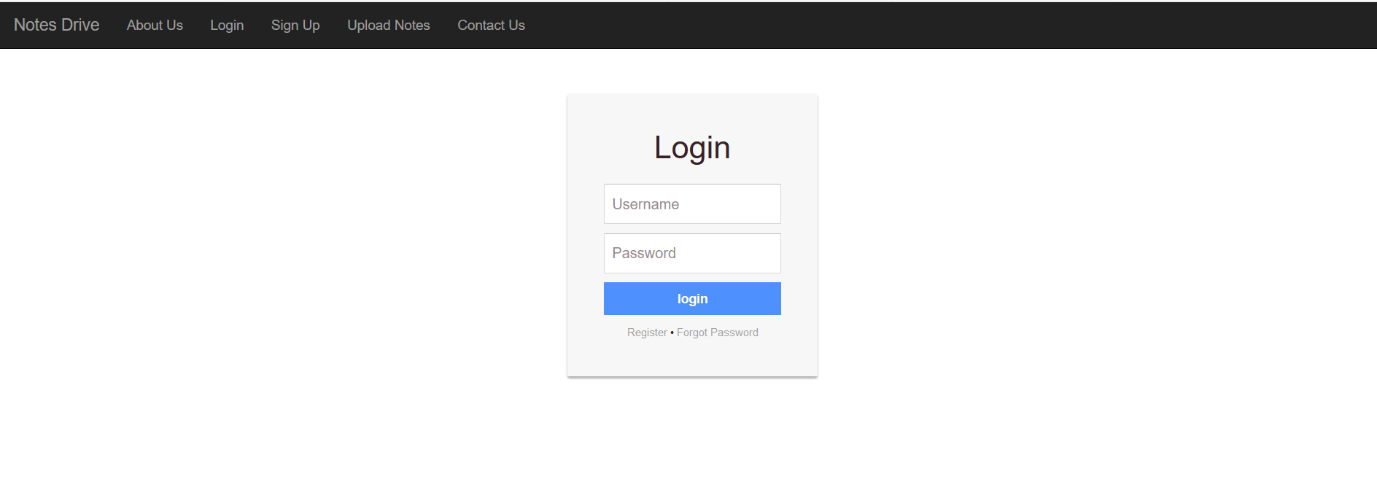

* Register Page

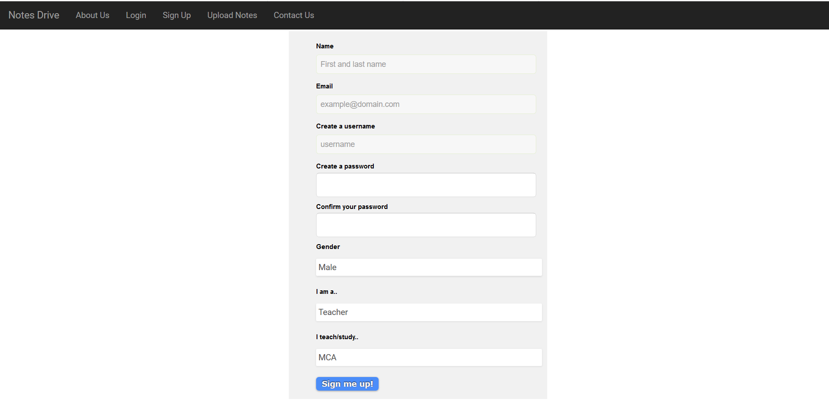

* Forget Password Page

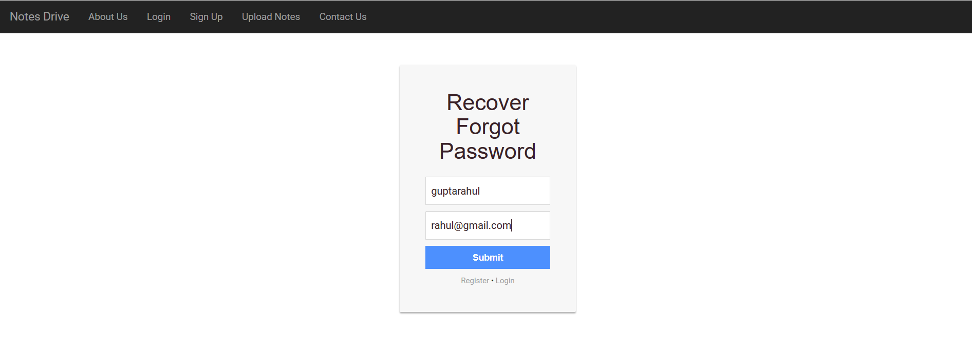

* Forget Password Recover Page

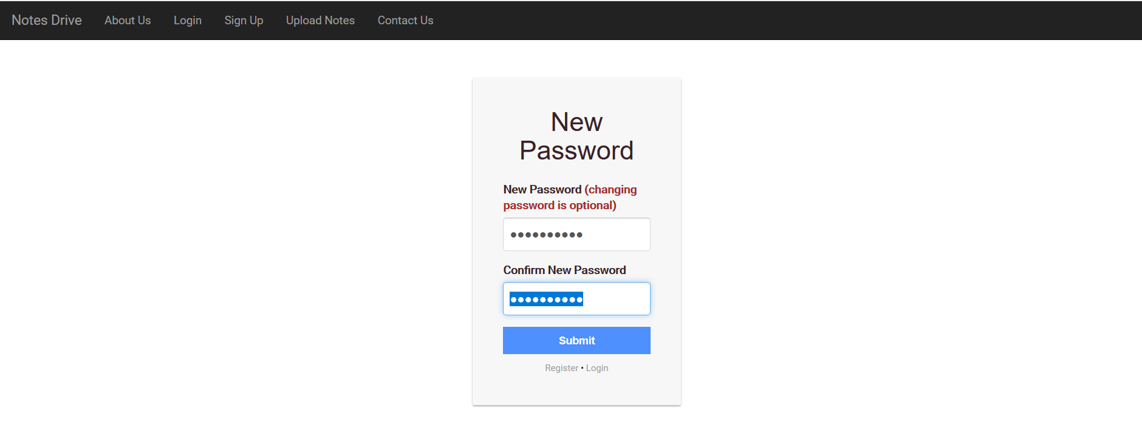

* Admin Dashboard Page

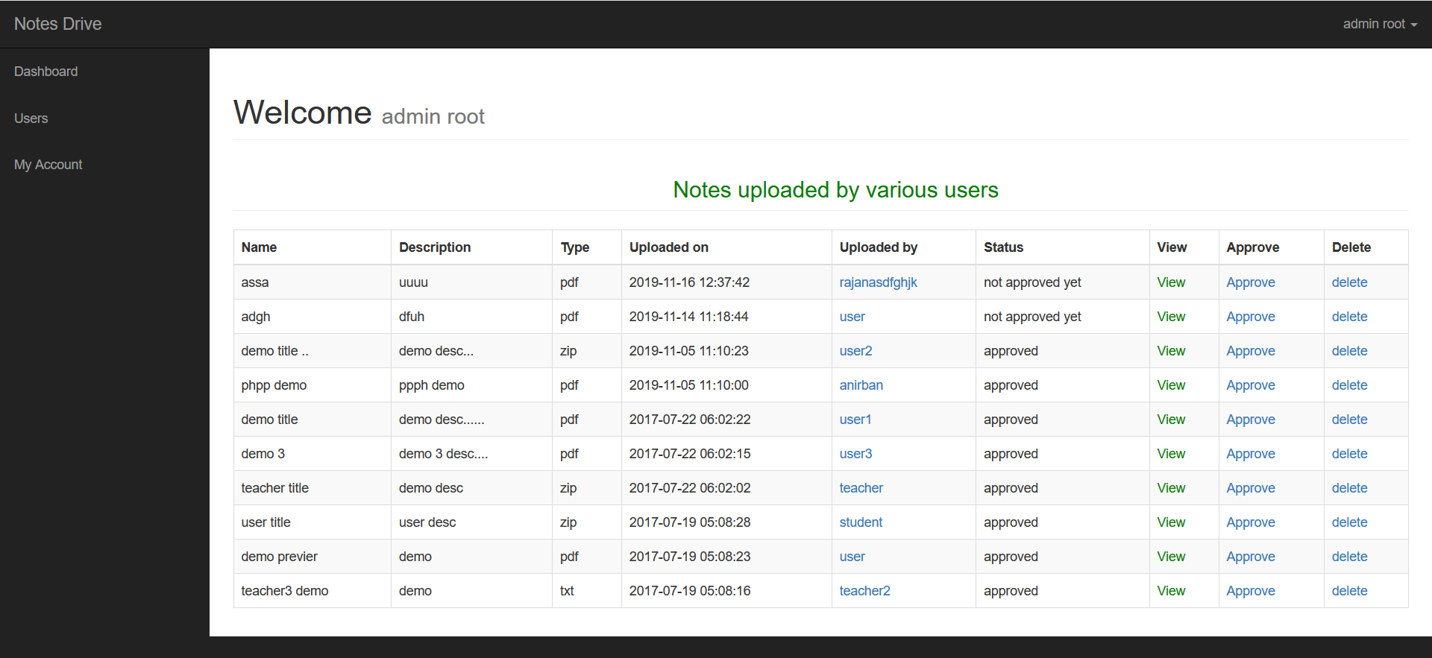

* Profile Page

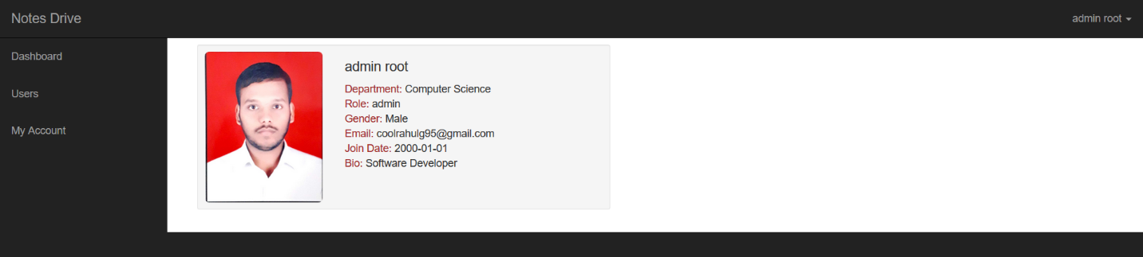

* Update Profile Page

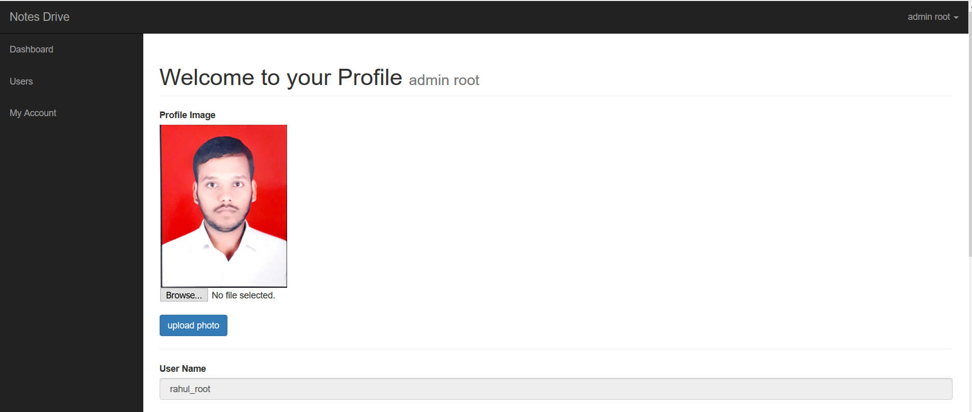

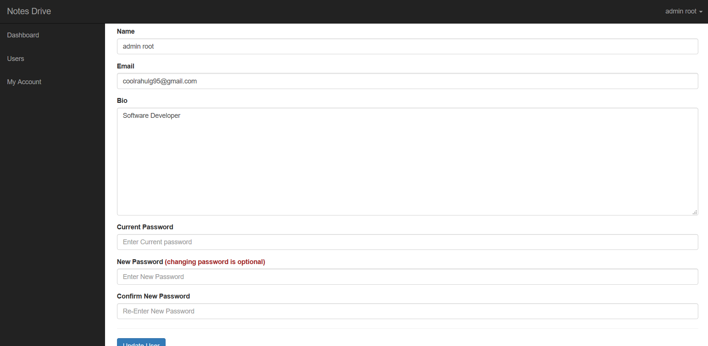

* User Dashboard Page

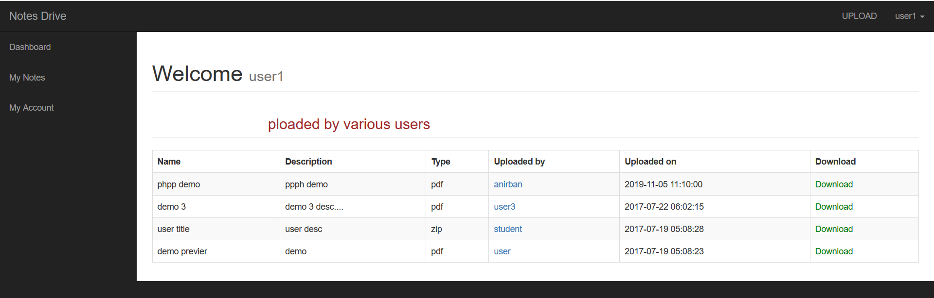

* Upload Notes Page

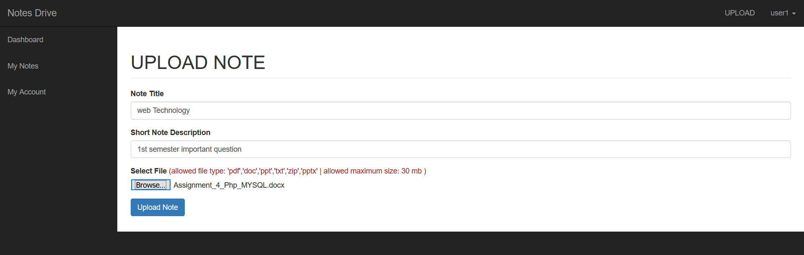

* Uploaded Notes Page

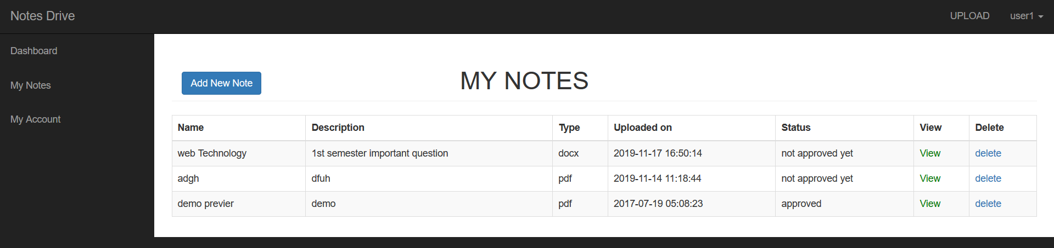

CONCLUSION

**Conclusion and Future Scope**

It has been a matter of immense pleasure, honors and challenge to have this opportunity to take up this project and complete it successfully. It was a nice experience working with the professors. This will be helpful when we will work in industry & educational field where we can put all these it in our practice.

While developing this system **NOTES DRIVE**, I have learnt a lot about the working of system. During the development process, I have understood the concept of designing and building a system. While working on my system I have used all the knowledge which was taught us and all that makes this project complete.

This website provides a computerized version of online Notes Drive which will benefit the students as well as the Teachers of the nation. It makes entire process online where student and teacher can search Notes. It also has a facility for student login and Teachers can login and can see the different kind of Notes available on this Notes drive and they can also upload their notes. It has a facility of teacher’s login where teachers can add lectures notes and also give necessary suggestion to students.

There is a future scope of to make easily available all notes and shared from each other in the Notes Drive website. This project thus making it more interactive more user friendly and project which fulfils each user need in the best way possible.

**BIBLIOGRAPHY**

For developing this project, I have referred to many of the books and websites which gave me immense knowledge to complete my project.

**Websites:**

* [www.stackoverflow.com](http://www.stackoverflow.com)
* [www.w3school.com](http://www.w3school.com)
* [www.slideshare.net](http://www.slideshare.net)
* [www.phpbuilder.com](http://www.phpbuilder.com)
* [www.developer.com](http://www.developer.com)
* www.javatpoint.com

**Books:**

* Reference books HTML and CSS by Jon Duckett.
* PHP and MYSQL web development by Luke Welling, Laura.